SHAQUILLLE NEIL

2330041

If a program is delete, all courses in that program must be deleted.

Updating ProgId in the programs table must propagate to the courses and students table.

We cannot delete a program in which there are students.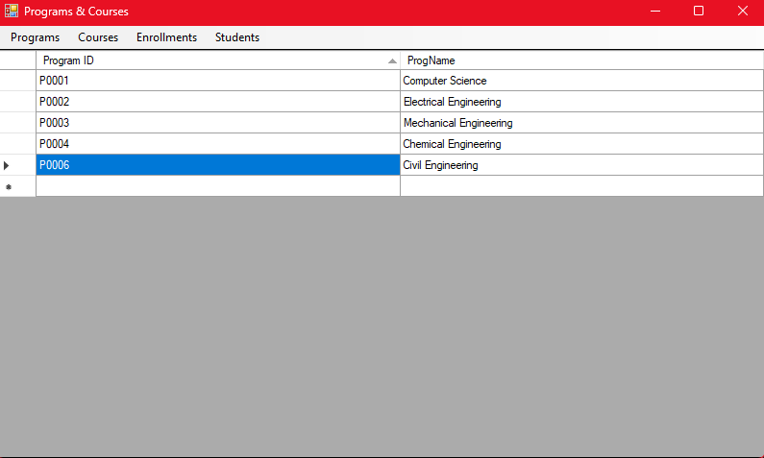

. If a student is deleted, all enrollments of that student must be deleted.

Updating the StId in the students table must propagate to the enrollments table.

We cannot delete a course to which there are enrolled students.

The CId of a course cannot be updated if there are enrollments to that course.

A student can enrol only to courses in the student's program.

Valid values of FinalGrade are null (no grade) or an integer between 0 and 100.

All enrollments are created with FinalGrade set to null.

FinalGrade can be removed (reset to null).

Once the FinalGrade is assigned, we cannot delete the enrollment and the only modification possible in the enrollment is to remove the final grade.

If the FinalGrade is not assigned, we can delete the enrollment and we can also change the course.